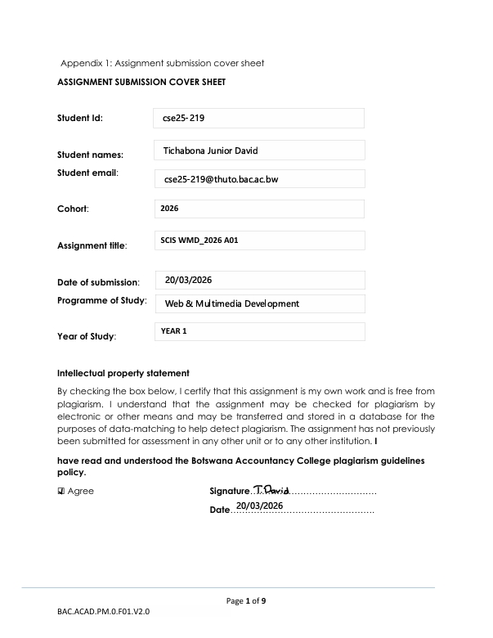
WMD ASSIGNMENT

- Website Specifications

Website name: AutoMarket BW

a) Website objective:
-The objective is to develop a one-stop automative marketplace website where buyers can browse and purchase a variety of vehicle related products. Whereas sellers can list and market vehicles, spare parts and accessories to potential customers.

The goal of the website is to:
- Connect buyers with sellers efficiently
-Provide easy access to everything car related
-To create a one-stop shop for car related products
- Allow businesses and individuals to advertise cars, car parts and accessories

b) Target audience:
Our target audience are:
-Car owners
-Mechanics
-Car buyers
-Car dealers
-Car parts and accessories vendors

Demographics:
Gender- All genders
Age- 18 to 60 years
Location- Any one in any location
Income levels- All income levels

Technical Aptitude:
-Familiar with browsing and online shopping
-Has smartphone, tablet or laptop
-Has good digital skills

c) Type of website:
AutoMarket BW Website is classified as an E-commerce and an Automative marketplace website where users can:
- Buy cars, accessories, and spare parts
-List cars, accessories and spare parts for sale

2. Information Design & Taxonomy

Site Map

Navigation Structure:
-Users will be able to access any page within three clicks(3-click rule),
this will help users to easily navigate the website and access
information easily

Content Categorization
Category | Links | Content Included
Home Page | index.htm | -Quick Links (Buy a car, Sell, Accessories, Spare parts), Search bar
Buy A Car | buycar.html | -Car details, Prices, Search bar
Sell | sell.html | -Sell a car, Sell a car, Sell accessories, Sell spare parts
Accessories | accessories.html | -Interior Accessories, Exterior Accessories, Electronics (sound systems, GPS devices)
Spare Parts | spareparts.html | -Engine parts, Tires and Wheels, Batteries
Contact | feedback.html | -Contact information, Feedback form

4. Technical Brief

Technologies:
-HTML5- Used to structure the content of web pages
-CSS3- Used to styling the website
-Bootstrap- Used to ensure responsiveness across different screen sizes
-JavaScript- Used for form validation

Development Tools:
-Notepad- used to create files
-Command Prompt- used to execute git commands
-GitHub- used to create and manage the repository
-GitHub Pages- hosts website from GitHub repository

Graphic tools:
-GIMP- used to create and edit images, logos and banners which will be used in the website

Testing Tools:
The following tools will be used to test for website responsiveness, layout consistency and functionality across different browsers:
-Google Chrome
-Microsoft Edge
-Mozilla Firefox

